Template for Departmental Activity Report

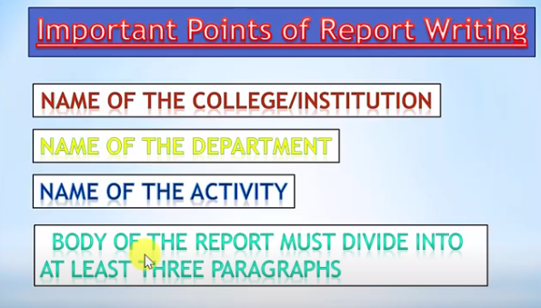
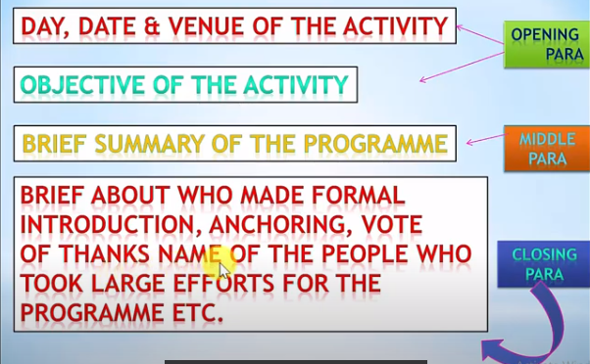
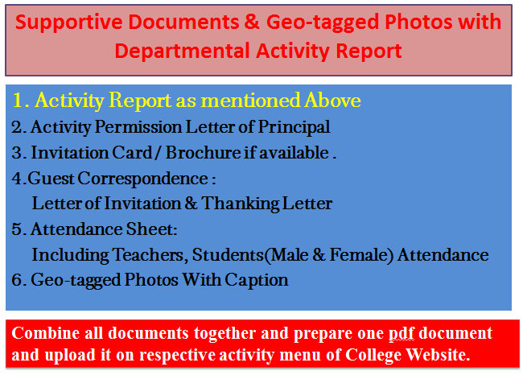
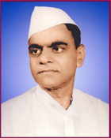
Janata ShikshanSanstha’s
Kisan Veer Mahavidyalaya,Wai
Department of N. C. C.
[Sample Report)
Collection of Offerings during Ganesh Immersion
Report
While Ganesh immersion people put offerings in river, which pollute water and harm nature as well, to aviode and make people aware about it on behalf of Kisan Veer Mahavidyalaya, the department of NCC organized “Collection of Offerings during Ganesh Immersion” at different Ghats on Krishna River on 07-09- 2019.
Almost 100 cadets collected offerings with request from people and gave the message to people of keeping river clean. Collected offerings were handed over to Wai Municipality for disposal, Lieutenant Sameer Pawar controlled the program.

College Seal
Dr. C. G. Yeole Lieutenant Sameer Pawar
Principal NCC Officer
Kisan Veer Mahavidyalay,Wai NCC Unit
2. Activity Permission Letter of Principal

Paste the PDF

4. 4.Guest Correspondence:
Letter of Invitation & Thanking Letter

Paste the PDF
3. Invitation Card / Brochure if available

Paste the PDF

Combine all documents together and prepare one pdf document and upload it on respective activity menu of College Website.
Caption
Caption
Paste the PDF
Paste the PDF
Caption
Caption
Paste the PDF
Paste the PDF
5. Geo-tagged Photos With Caption

Paste the PDF
5. Attendance Sheet:
Including Teachers, Students
(Male & Female) Attendance

